Software Design Document
<Transition Network Analysis Of Course Interaction Data>



Submitted by
Name: Abu Rehan
Roll No: F22BINFT1M01272

Submitted to
Dr. Mustafa Hameed

Department of Information Technology
Faculty of Computing
The Islamia University of Bahawalpur

Summary
This Software Design Document (SDD) describes the design and architecture of a web-based Student Behavior Analysis System developed to study student interactions within a Learning Management System (LMS). The purpose of the system is to analyze LMS interaction logs and identify meaningful learning behavior patterns by examining the sequence of activities performed by students.
The system is implemented as a standalone web application that allows users to upload exported LMS datasets and process them through a structured analytical workflow. It follows a layered architecture inspired by the Model–View–Controller (MVC) pattern, which separates user interaction, request handling, analytical processing, and data management. This design approach improves clarity, maintainability, and scalability of the system.
The core analytical process includes data validation, preprocessing, sequence generation, construction of transition networks, computation of network metrics, and clustering of student behavior patterns. These steps are executed through a modular pipeline that ensures each stage of analysis is clearly defined and independently manageable. Analytical and visualization tasks are supported using Python-based libraries such as Pandas, NetworkX, and Scikit-learn.
Results are presented through a user-friendly dashboard that displays graphical and statistical summaries of student behavior. The system also provides export functionality, allowing users to download processed data and visual outputs for further analysis. Overall, the proposed design offers a practical and flexible framework for analyzing student learning behavior and supporting data-driven educational research.

Table of Content

1. Application Architecture
2. Data Model Schema
3. User Interface
4. Design Decisions
5. Algorithm & Methodology
6. Security And Data Privacy
7. Deployment And Operations
8. Testing Strategy
9. Conclusion
Appendices A–D

- Application Architecture
The proposed system is a web-based application developed using Flask that follows a layered MVC-inspired architecture. User requests from the browser are handled by controllers, which invoke a service-layer processing pipeline consisting of validation, preprocessing, sequence generation, transition network construction, metrics computation, and clustering. The processed results are stored in the data layer and presented to the user through a results dashboard with export functionality.

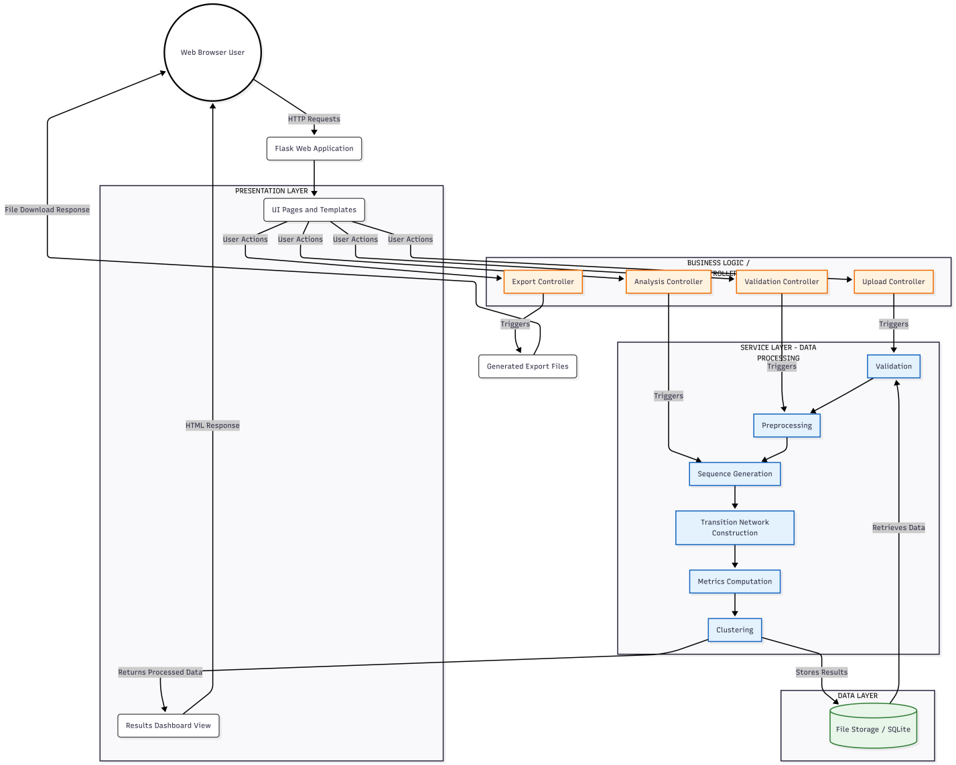

Figure1: System Context Diagram

  - Core Components
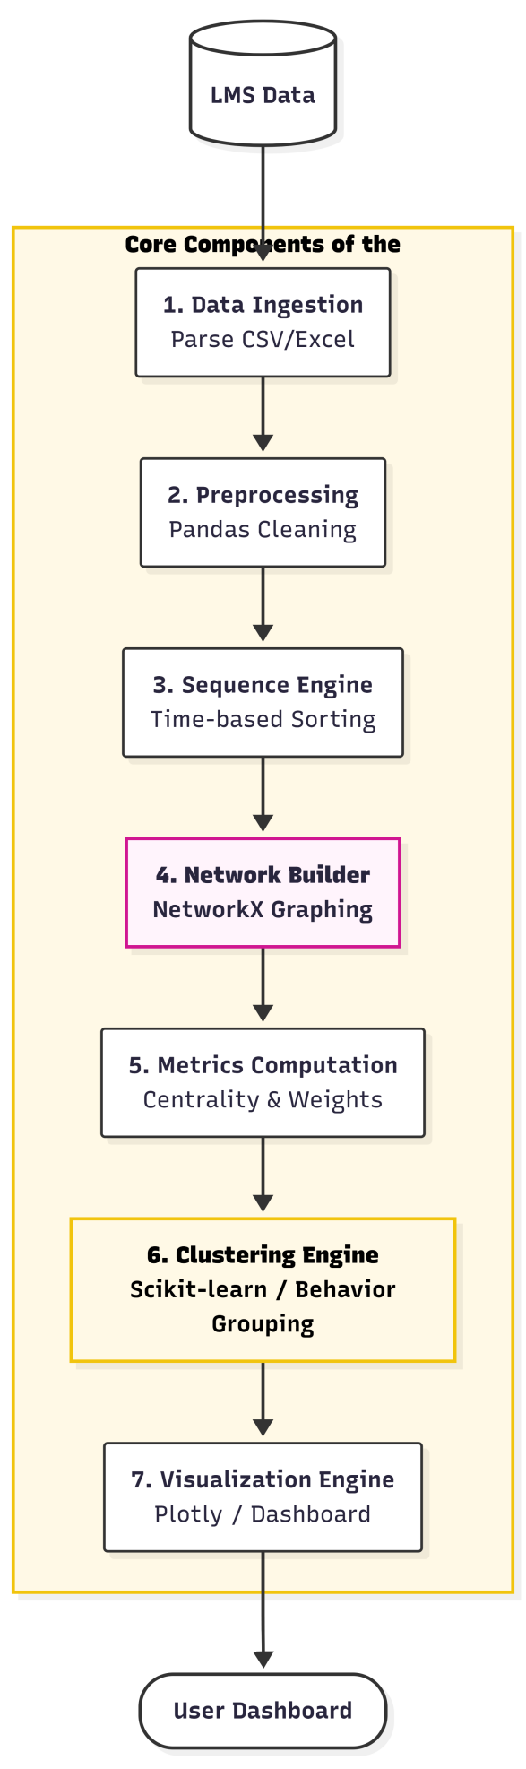

Figure2: Component Diagram
The system consists of seven primary components
1. Data Ingestion: Reads raw LMS interaction logs from CSV or Excel files and prepares them for processing.
2 .Preprocessing: Cleans the dataset by handling missing values, removing inconsistencies, and standardizing data formats using Pandas.
3. Sequence Engine: Organizes student activities into time-ordered sequences to capture the chronological learning behavior of each student.
4. Network Builder: Constructs transition networks using NetworkX, where nodes represent learning activities and edges represent transitions between them.
5. Metrics Computation: Calculates network-based metrics such as centrality measures and transition weights to quantify learning behavior patterns.
6. Clustering Engine: Groups students into behavior-based clusters using machine learning techniques provided by scikit-learn.
7. Visualization Engine: Displays analytical results and behavior clusters through interactive graphs and dashboards using Plotly.

- Data Model Schema
Detail of database conceptual schema will be provided here. Each data model entity will be explained in details, its working properties and relationship with other entities. Authors will also provide ER diagram to explain the working entities.

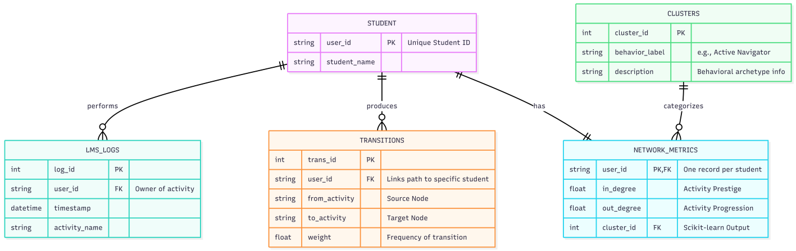
Figure 3: Entity Relationship Diagram

2.1.1 STUDENT (Reference / Dimension Table)

Column Name | Type | Key | Description
user_id | string | PK | Unique student identifier used across the system
student_name | string | — | Student name (optional, if available in dataset)

2.1.2 LMS_LOGS (Fact / Raw Input Table)

Column Name | Type | Key | Description
log_id | int | PK | Unique identifier for each log entry (can be generated if missing)
user_id | string | FK | References STUDENT.user_id
timestamp | datetime | — | Time when the activity occurred
activity_name | string | — | Name of the activity/resource accessed by the student

2.1.3 TRANSITIONS (Derived / Intermediate Table)
Column Name | Type | Key | Description
trans_id | int | PK | Unique identifier for each transition record
user_id | string | FK | References STUDENT.user_id (links transitions to a specific student)
from_activity | string | — | Source activity in the transition
to_activity | string | — | Target activity in the transition
weight | float | — | Transition frequency/weight between the two activities

2.1.4 NETWORK_METRICS (Analytical Output Table)
Column Name | Type | Key | Description
user_id | string | PK, FK | References STUDENT.user_id (one record per student)
in_degree | float | — | Incoming transition count/weight for the student’s network
out_degree | float | — | Outgoing transition count/weight for the student’s network
cluster_id | int | FK | References CLUSTERS.cluster_id

2.1.5 CLUSTERS (Reference / Result Mapping Table)
Column Name | Type | Key | Description
cluster_id | int | PK | Unique identifier for each behavior cluster
behavior_label | string | — | Human-readable cluster label (e.g., Active Navigator)
description | string | — | Short description of the behavior pattern

- User Interface
Overall design philosophy such as color scheme, font, design niche and screen constraints (if required then responsiveness or targeted screens size) will be discussed here. List of screens/pages will be provided and explain the data on each page/screen. List of controls (Textbox, Drop Down, Buttons etc.) on each page will be provided and explain the working of data. Also explain the input constraints.

3. User Interface
3.1 Input/Output Interfaces
- Inputs: CSV/Excel LMS interaction logs uploaded by the user (admin/teacher).
- Outputs: Interactive dashboard views (network metrics, cluster summaries, charts) and downloadable exports (CSV/Excel reports and plots).

3.2 Conceptual Dashboard
- Upload View: File upload with validation status and error messages.
- Results Dashboard: Cluster overview, metrics summaries, and visual charts of learning behavior patterns.
- Export View: Options to download processed datasets and generated figures.
This is the same structure as the sample, but 100% aligned to your project.

4. Design Decisions
- Sequence-based Modeling:
Student interaction data is modeled as ordered activity sequences to preserve the temporal nature of learning behavior and enable transition analysis.
- Transition Network Representation:
Learning behavior is represented as directed networks, allowing relationships between consecutive activities to be captured and analyzed using network metrics.
- Network-based Feature Selection:
Network metrics such as in-degree and out-degree are used as features because they provide compact and interpretable summaries of student navigation patterns.
- Clustering-based Behavior Analysis:
Unsupervised clustering is adopted to group students based on behavioral similarity, as predefined labels for learning behavior are not available.

5. Algorithm & Methodology

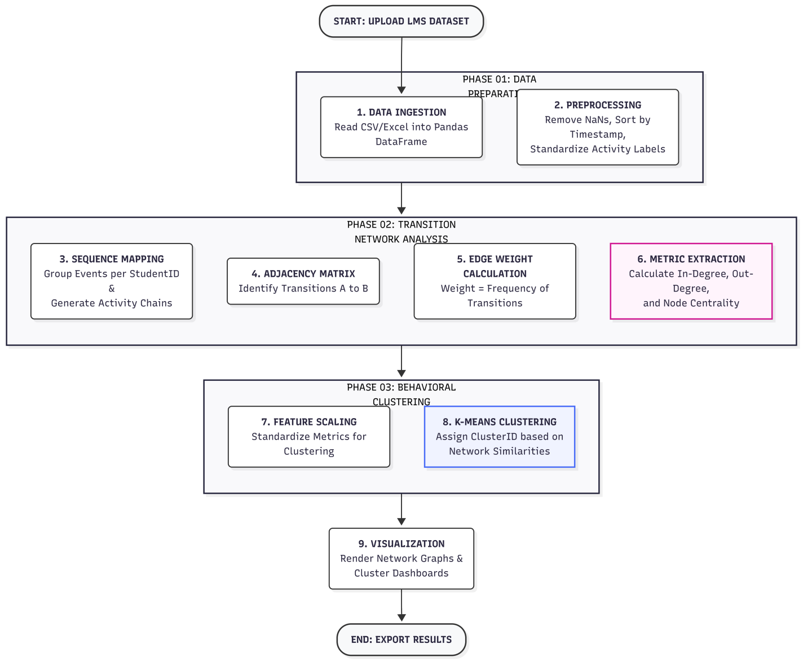
Figure 4: Algorithm and Methodology Diagram

5.1 Feature Engineering
The system derives features from student transition networks to summarize learning behavior patterns.
Key features include:
• Network Degree Metrics: In-degree and out-degree values representing how frequently a student enters or exits learning activities.
• Transition Weights: Frequency of transitions between activity pairs, capturing navigation intensity.
• Structural Indicators: Aggregated network measures used as inputs for behavioral clustering.

5.2 Data Flow Logic
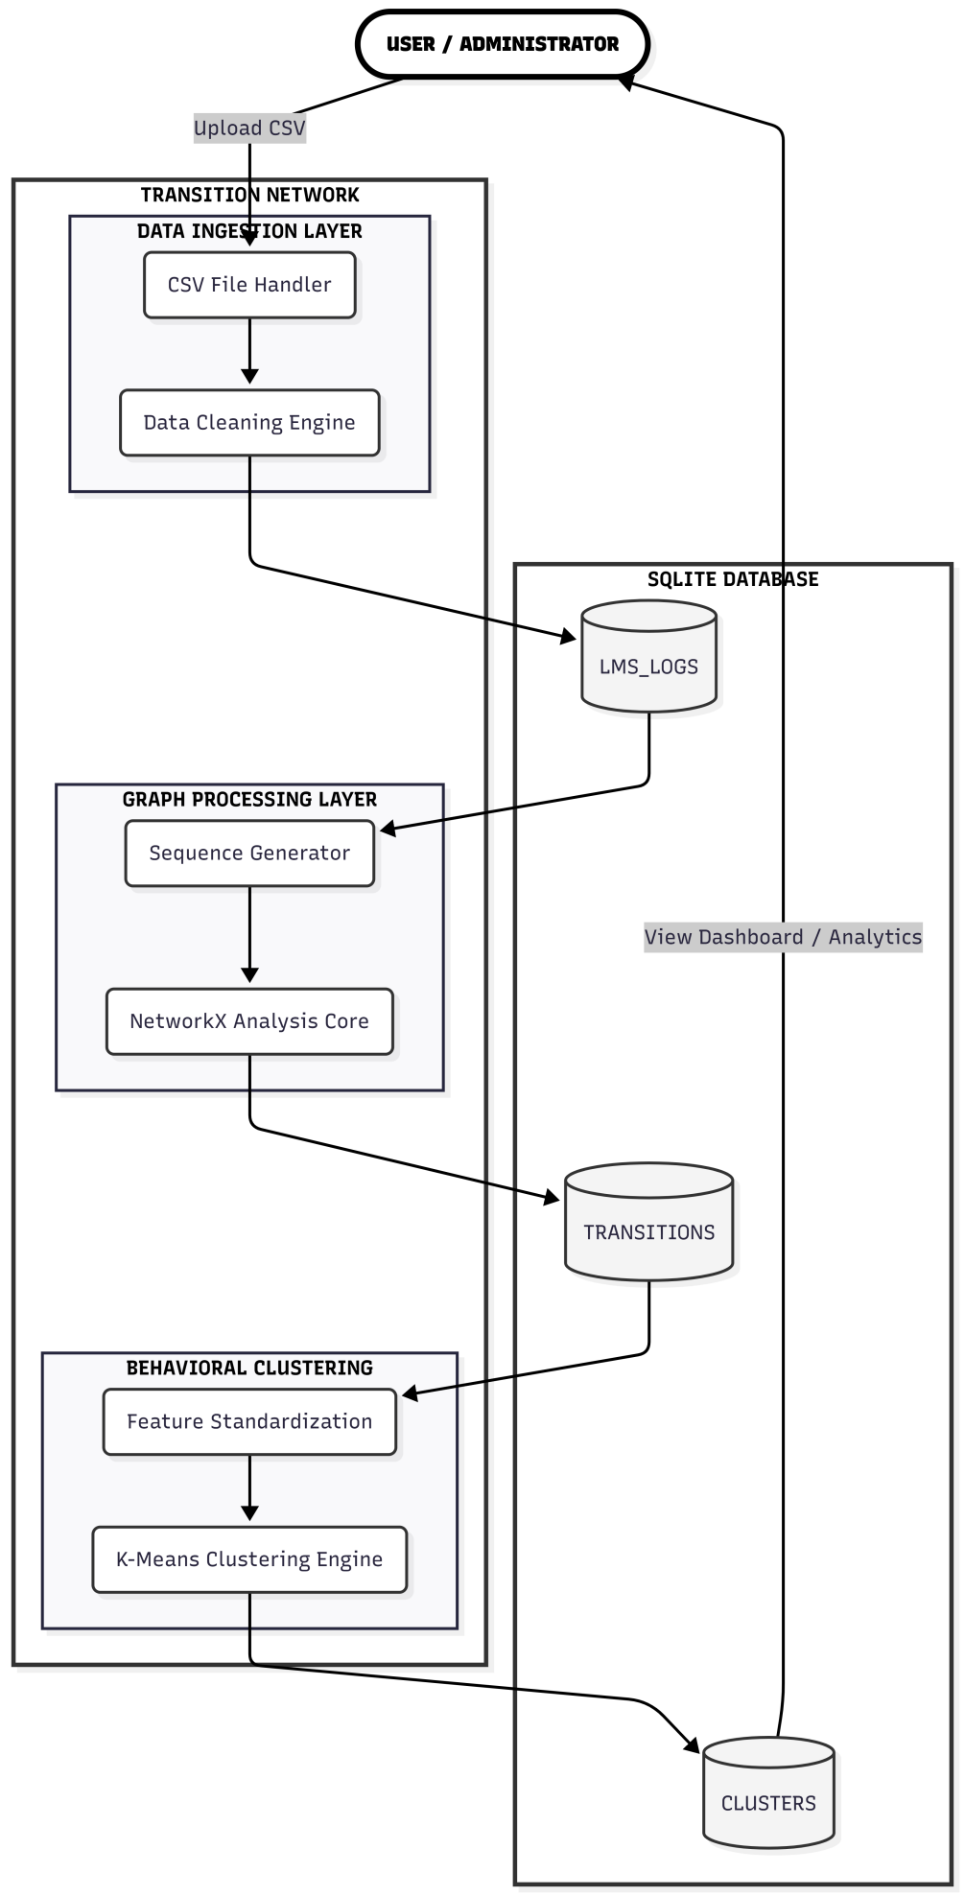
Fig 5.2: Data Flow Logic

6. Security and Data Privacy
The system is designed with student data privacy in mind. All learning data is processed using pseudonymized student identifiers instead of real names or personal information. This ensures that individual students cannot be directly identified during analysis. Access to the system and generated results is limited to authorized users such as instructors or administrators. The processed datasets are used strictly for academic analysis and research purposes.

7. Deployment and Operations
The system operates in a batch-processing mode, where LMS interaction data is analyzed periodically rather than in real time. Typically, data processing is performed on a weekly basis to reflect recent learning activity trends. Each analytical run follows a consistent processing pipeline, allowing results to be reproduced and compared over time. This design supports stable operation throughout the academic term while keeping system complexity manageable

- Testing Strategy

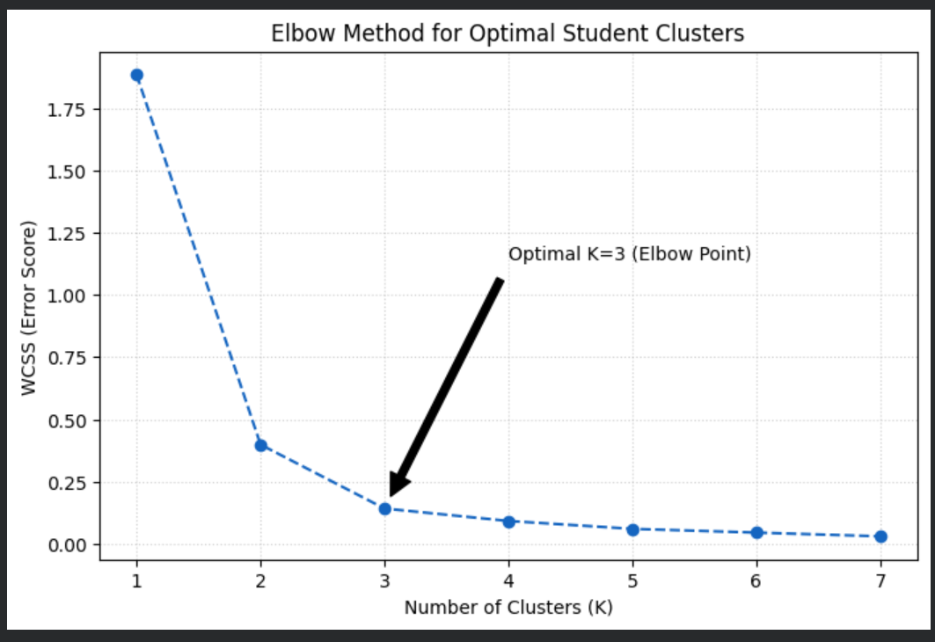

- The elbow method was used to identify the optimal number of clusters by observing diminishing returns in WCSS reduction. The elbow point at K=3 indicates a balance between model simplicity and behavioral differentiation.

Appendix A: Feature Dictionary
This section provides descriptions of the key features extracted from the LMS logs for analysis. It is important for understanding the data attributes used for predicting student behavior patterns.

Feature | Description
activity_count | Total number of interactions or activities recorded by each student.
study_session_count | Number of study sessions for each student based on activity logs.
average_session_duration | Average time duration of each study session across all logs.
entropy_daily_activity | A measure of the randomness in daily student activity, helping to identify consistent vs. inconsistent study patterns.
median_session_length | The median duration of study sessions for each student.

Appendix B: Configuration
This appendix outlines the configuration parameters used in the project, especially for machine learning models and system setup. These configurations may influence system performance or affect model outcomes.
# Future Classification Modules
RF_N_ESTIMATORS = 200 # Number of trees in the Random Forest model
RF_MAX_DEPTH = 10 # Maximum depth of each tree in the Random Forest
RF_MIN_SAMPLES_SPLIT = 2 # Minimum number of samples required to split a node
# Clustering Configuration
K_MEANS_N_CLUSTERS = 3 # The number of clusters for K-Means Clustering

Appendix C: Glossary
- Sessionization: The process of grouping raw student activity logs into meaningful study sessions based on time intervals. It ensures that each session is treated as a distinct study period for analysis.
- Entropy: A measure of randomness or unpredictability. In this project, it is used to evaluate the consistency of student study behavior. Low entropy indicates erratic study patterns, while high entropy shows consistent study behavior.
- FERPA: The Family Educational Rights and Privacy Act is a US law that protects the privacy of student education records. This project ensures that data handling and processing comply with FERPA to maintain student privacy.
- LMS: Learning Management System — software used by educational institutions to deliver content, track student progress, and manage administrative functions.

Appendix D: Diagrams & Flowcharts
This appendix includes the diagrams and flowcharts that depict the system architecture, data flow, and machine learning pipeline. These diagrams are essential for understanding the overall structure and workflow of the system.
- System Architecture Diagram: Shows the layers of the system, including data ingestion, data processing, machine learning components, and visualization.
- Data Flow Diagram (DFD): Illustrates how data flows through the system, starting from the CSV upload, passing through the processing layers, and ending at the visualization in the dashboard.
- Machine Learning Workflow: Depicts how student interaction data is processed, the transition network is built, and clustering is applied to group students based on their behavior.

